**STRING array**

In C programming, a string is a sequence of characters terminated with a null character \0. For example:

char c[] = "c string";

When the compiler encounters a sequence of characters enclosed in the double quotation marks, it appends a null character \0 at the end by default.

Memory diagram of strings in C programming

**How to declare a string?**

Here's how you can declare strings:

char s[5];

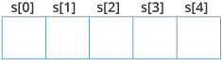

Here, we have declared a string of 5 characters.

**How to initialize strings?**

You can initialize strings in a number of ways.

char c[] = "abcd";

char c[50] = "abcd";

char c[] = {'a', 'b', 'c', 'd', '\0'};

char c[5] = {'a', 'b', 'c', 'd', '\0'};

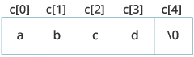

Let's take another example:

char c[5] = "abcde";

Here, we are trying to assign 6 characters (the last character is '\0') to a char array having 5 characters. This is bad and you should never do this.

### Example 1: scanf() to read a string

#include <stdio.h>

int main()

{

char name[20];

printf("Enter name: ");

scanf("%s", name);

printf("Your name is %s.", name);

return 0;

}

**Output**

Enter name: Dennis Ritchie

Your name is Dennis.